01 Feb 2021

For this reaction 6 different solutions were made. Samples 1, 2, and 3 included the first three primer sets (in order) mixed in TE with no template. Samples 4, 5, and 6 included the three primer sets (in order) along with equal amounts of the template.

The three primer sets are labeled as follows:

1. IDMO100.MS2.01F and IDMO101.MS2.01R
2. IDMO102.MS2.02F and IDMO103.MS2.02R
3. IDMO104.MS2.03F and IDMO105.MS2.03R

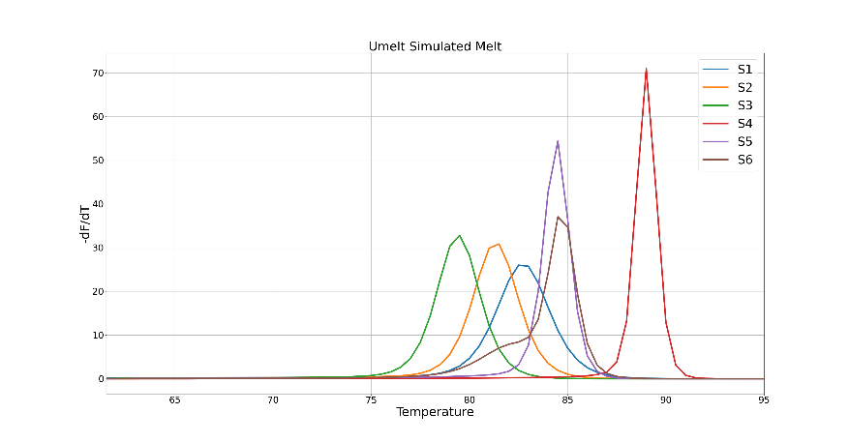 uMELT Quartz (<https://dna-utah.org/umelt/quartz/>) was used to produce a simulated melting curve to compare with experimental data:

Simulated Tm:

S4) 87.29

S5) 82.0

S6) 82.01

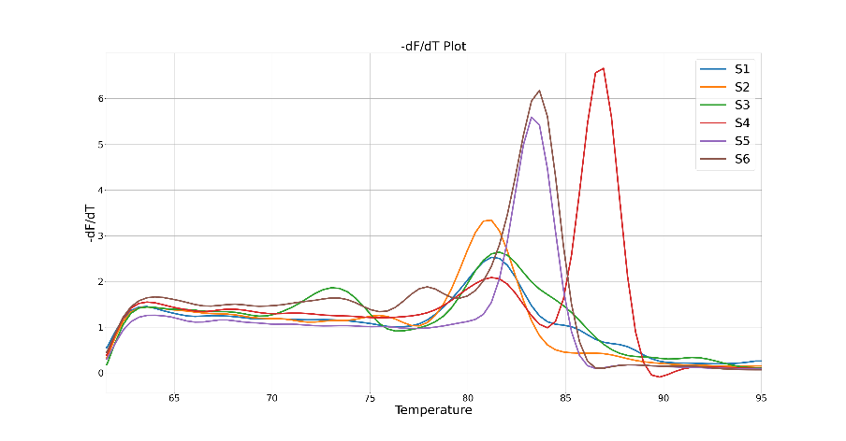

Experimental Tm:

S4) 86.28

S5) 82.96

S6) 82.65

The experiment produced data represented by the following curves:

* Primers were designed using Primer3 (<https://bioinfo.ut.ee/primer3-0.4.0/>)
* Primers were supplied by Integrated DNA Technologies (IDT)( <https://www.idtdna.com/pages>)